Neolithic/Paleolithic Document Based Analysis

Instructions: This question is based on the accompanying documents. The question is designed to test your ability to work with historical documents. Some of these documents have been edited for the purpose of this question. As you analyze the documents, take into account the source of each document and any point of view that may be presented in the document.

Historical Context: One of the most important turning points in human history was the change that occurred during the Neolithic Revolution. This shift from the Paleolithic Era to the Neolithic Era changed the course of the human race. Task: Using the information from the documents and your knowledge of global history, answer the questions that follow each document.

Document 1
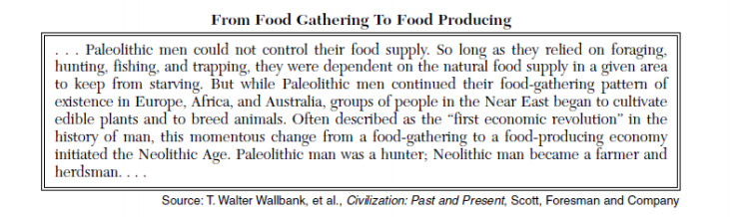

According to the authors of this passage, what is one significant change that occurred between the Paleolithic Era and Neolithic Era?

Document 2a & 2b

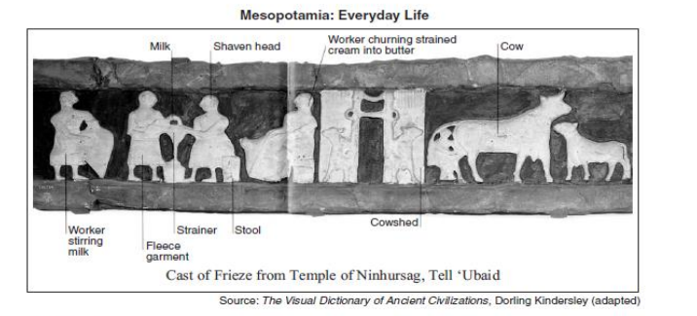
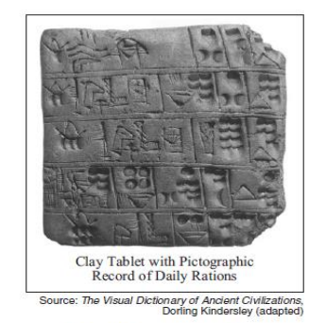
Based on these images, state one advancement that occurred as the Mesopotamian culture developed a stable food supply?

Document 3

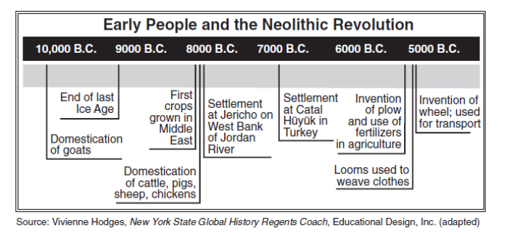

Bases on this timeline, identify two ways that people’s lives changed during the Neolithic Revolution?

Document 4

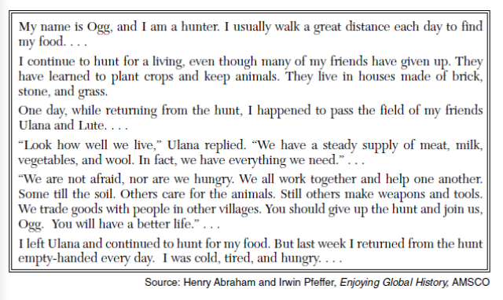
Identify one way that progress during the Neolithic Revolution helped Ulana and her friends.

Document 5

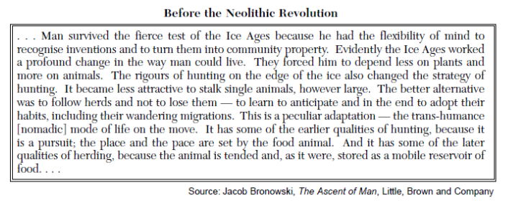

Based on this document, identify two characteristics of life before the Neolithic Revolution.

Document 6

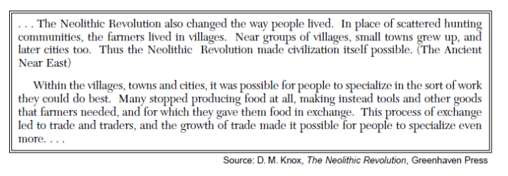
Based on this document, state one impact of the Neolithic Revolution on the way people lived.

